Bahria University,

Karachi Campus



LAB EXPERIMENT NO.

___03___

LIST OF TASKS

|  |  |
| --- | --- |
| TASK NO | OBJECTIVE |
| **01** | Write a single shell script that creates four different files, while taking the names of all created files as input from the user. As the files content, insert your name in the first file, registration number in the second and section details in the third. These should be followed by merging the contents of all three files into the fourth one. |
| **02** | Write a shell script to count all files and folders present in directory and stored the output into a text file and display its content on the terminal. |
| **03** | **Create a .txt file and input ten lines of entry while mixing it with both alphanumeric characters. Sort the contents of the created file in an ascending order and write the sorted output into another file.** |
| 04 | write a Program to Sum of Natural Numbers Using for Loop |

Submitted On:

23-03-2023

(Date: DD/MM/YY)

**Task 01:** Write a shell script to count all files and folders present in directory and stored the output into a text file and display its content on the terminal.

**Solution:**

#!/bin/bash

ls -l < filecount.txt

wc -l > filecount.txt

**Output:**

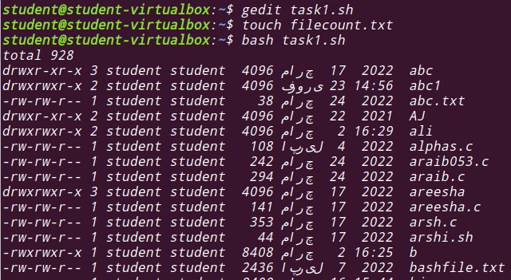

**Task 02:** Write a single shell script that creates four different files, while taking the names of all created files as input from the user. As the files content, insert your name in the first file, registration number in the second and section details in the third. These should be followed by merging the contents of all three files into the fourth one.

**Solution:**

#!/bin/bash

echo "Enter First File"

read firstFile

echo "Enter Name"

read name

echo "My name is $name" > $firstFile

echo "Enter Second File"

read secondFile

echo "Enter registration Number"

read regirstration

echo "The registration number is $regirstration" > $secondFile

echo "Enter Third File"

read thirdFile

echo "Enter section details"

read sd

echo "The section details is $sd" > $thirdFile

echo "Enter Fourth File"

read fourthFile

cat $firstFile $secondFile $thirdFile > $fourthFile

cat $fourthFile

**Output:**

